SPRINT 1

|  |  |
| --- | --- |
| TEAM ID | PNT2022TMID50061 |
| PROJECT NAME | Real-Time River water Quality Monitoring and  Control System |

REGISTRATION PAGE:

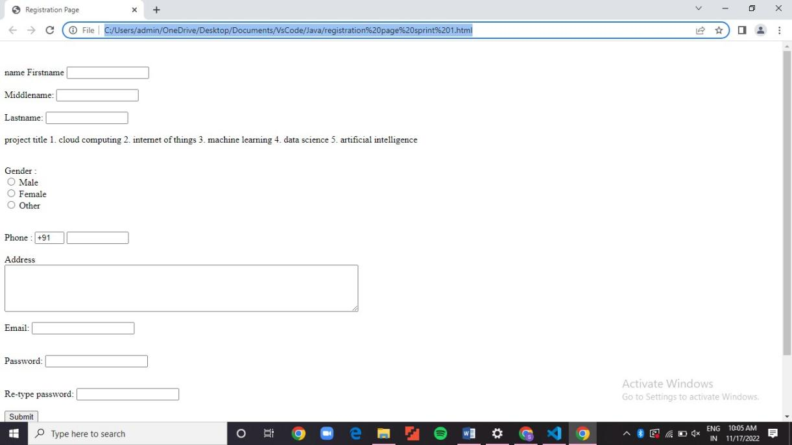

CODE:

<html>

<head>

<title> Registration Page

</title>

</head>

<body>

<br>

<br>

<form> name

<label> Firstname </label>

<input type="text" name="firstname" size="15"/> <br> <br>

<label> Middlename: </label>

<input type="text" name="middlename" size="15"/> <br> <br>

<label> Lastname: </label>

<input type="text" name="lastname" size="15"/> <br> <br>

</select> project title

1.<label> cloud computing </label> 2.<label> internet of things </label> 3.<label> machine learning </label> 4.<label> data science </label> 5.<label> artificial intelligence </label>

<br>

<br>

<br>

<label> Gender :

</label><br>

<input type="radio" name="male"/> Male <br>

<input type="radio" name="female"/> Female <br>

<input type="radio" name="other"/> Other

<br>

<br>

<br>

<label> Phone :

</label>

<input type="text" name="country code" value="+91" size="2"/>

<input type="text" name="phone" size="10"/> <br> <br> Address

<br>

<textarea cols="80" rows="5" value="address">

</textarea>

<br> <br>

Email:

<input type="email" id="email" name="email"/> <br>

<br> <br> Password:

<input type="Password" id="pass" name="pass"> <br>

<br> <br>

Re-type password:

<input type="Password" id="repass" name="repass"> <br> <br>

<input type="button" value="Submit"/>

</form>

</body>

alternte phone number

<input type="text" name="country code" value="+91" size="2"/>

<input type="text" name="phone" size="10"/> <br> <br> alternate email id

<input type="altrernate email id" name="alternate email"/> <br>

<br> <br>

<body>

<html>